Order Of Service

Singing: Psalm 23—CW page 72

Reading: Psalm 33

Opening Hymn: TLH 19

Reading: II Corinthians 5:1-10

Request Hymn: CW Supplement 730

Reading: Mark 5:21-34

Sermon Hymn: TLH 17

Sermon Text: Luke 15:25-32

The Other Son

Prayer

The Apostles’ Creed, TLH page 12

Holy Communion

The Lord's Prayer

The Blessing

Closing Hymn: TLH 15

************

Bible Study: Lambs: Beagle Hound
Sheep: Genesis - Revelation
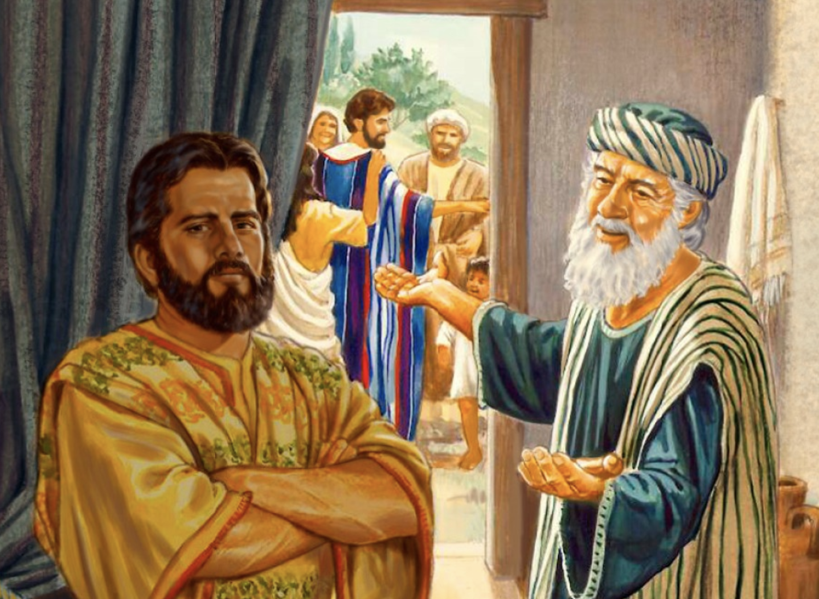

The Other Son

Water
Of
Life

31 July 2022

W A T E R O F L I F E

Independent Christian Church—Conservative Lutheran Doctrine

Worship Service: 9:30 a.m.

Larry Cooper, Pastor E-Mail address:
111 N. Ridge Road lcooper@wateroflife.cc
Coon Valley, WI 54623 Web Site:
www.wateroflife.cc

* * * * * * * * * * * * * * * * * * * * * * * * * * *

Sermon Text: Luke 15:25-32

The Other Son

* * * * * * * * * * * * * * * * * * * * * * * * * * *

25 Now his elder son was in the field: and as he came and drew nigh to the house, he heard musick and dancing.
26 And he called one of the servants, and asked what these things meant.
27 And he said unto him, Thy brother is come; and thy father hath killed the fatted calf, because he hath received him safe and sound.
28 And he was angry, and would not go in: therefore came his father out, and intreated him.
29 And he answering said to his father, Lo, these many years do I serve thee, neither transgressed I at any time thy commandment: and yet thou never gavest me a kid, that I might make merry with my friends:
30 But as soon as this thy son was come, which hath devoured thy living with harlots, thou hast killed for him the fatted calf.
31 And he said unto him, Son, thou art ever with me, and all that I have is thine.
32 It was meet that we should make merry, and be glad: for this thy brother was dead, and is alive again; and was lost, and is found.

